Name - Cherukuri V V M Subhash

Btech - CSE,3rd year

AI related course work / project / experience: This is my first AI project, and I do not have prior coursework or experience in this field.

# Milestone 1 - Completed

# Mile stone 2 - Completed

The U-Net model was trained using 80 training images and evaluated on 20 test images for semantic segmentation.

* U-Net IoU Score: **8.49%**
* U-Net Dice : **7.8%**

**My Yolo Model Evaluation and Results Analysis**

| **Metric** | **Value** |
| --- | --- |
| Precision | **97.4%** |
| Recall | **28.6%** |
| mAP@0.5 | **34.3%** |
| mAP@0.5:0.95 | **16.1%** |

# 

# 

# Mile Stone 1 Dataset Collection and Preparation

## **Week 1 Day 1**

**Findings:**

1. We are build an AI system that uses satellite and drone images to help archaeologists:
   1. Identify and segment **ancient ruins** and **vegetation.**
   2. Detect and classify **artifact structures.**
   3. Predict **areas that will face erosion** in the future.
   4. Display all results on an **interactive dashboard**

**Ruins**: Old broken structures built by humans (walls, foundations, temples, ancient buildings).

**Vegetation**: All plant life such as trees, grass, bushes, and forest cover.

**Detect and classify artifact structures** means training an AI model to locate ancient man-made structures in images and automatically identify what type of structure each one is.

**Predicting future erosion zones** means using AI and terrain/environment data to find which parts of an archaeological site are likely to lose soil or get damaged in the future.

| **Aspect** | **Details** |
| --- | --- |
| Objective | To identify archaeological ruins and vegetation from satellite imagery using AI |
| Problem Type | Semantic Segmentation |
| Data Source | Google Earth Pro |
| Output Required | Pixel-wise labeled masks |

**Activities Performed:**

* Studied project problem statement and milestones.
* Understood difference between semantic segmentation and object detection.
* Identified key classes required for segmentation.
* Planned data collection and annotation workflow.

## **Week 1 Day 2**

**Findings:**

I think this 5 datasets helps for preparation for my dataset:

1.**ALOS Landforms** (Global ALOS Landforms)

2.OAM aerial/drone imagery.

3.OAM orthophotos / orthomosaics.

4.DEM / Elevation / Surface Models (GEE).

5.Multispectral / optical satellite imagery (GEE).

| **Aspect** | **Details** |
| --- | --- |
| Tool Used | Google Earth Pro |
| Image Type | Satellite screenshots |
| Format | PNG |
| Variations | Different zoom levels and angles |

**Activities Performed:**

* Explored multiple geographical regions.
* Collected images containing ruins, vegetation, and terrain.
* Ensured variation in scale and viewpoint.
* Saved images systematically.

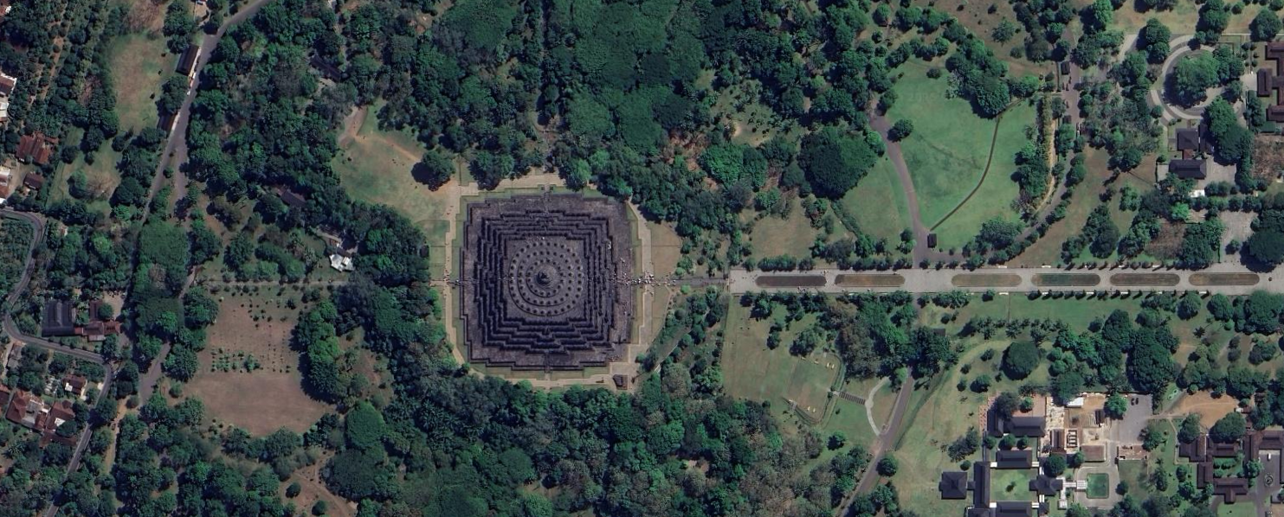

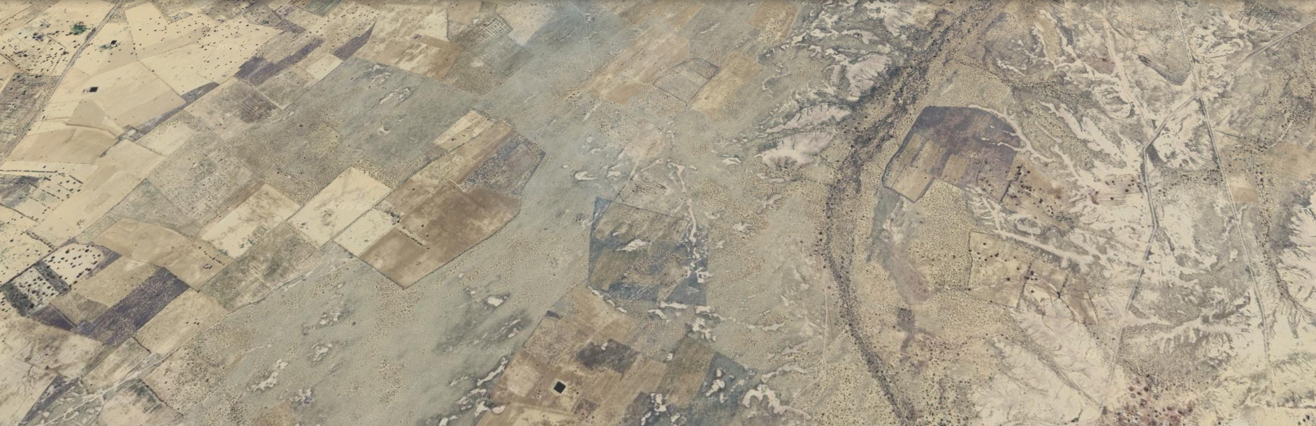

## **Day 3: Dataset Organization & Cleaning**

| **Folder** | **Description** |
| --- | --- |
| ruins | Images with visible archaeological structures |
| vegetation | Images with dense forest/tree regions |
| terrain | Images with open land/background |

**Activities Performed:**

* Organized images into class-based folders.
* Removed unclear, duplicate, or low-resolution images.
* Verified dataset consistency.

## **Day 4: Labelbox Setup & Project Configuration**

| **Aspect** | **Details** |
| --- | --- |
| Annotation Tool | Labelbox |
| Annotation Type | Polygon-based segmentation |
| Classes Defined | Background, Ruins, Vegetation, Terrain |

**Activities Performed:**

* Created Labelbox account.
* Uploaded dataset images.
* Configured segmentation project.
* Defined labeling ontology.  
  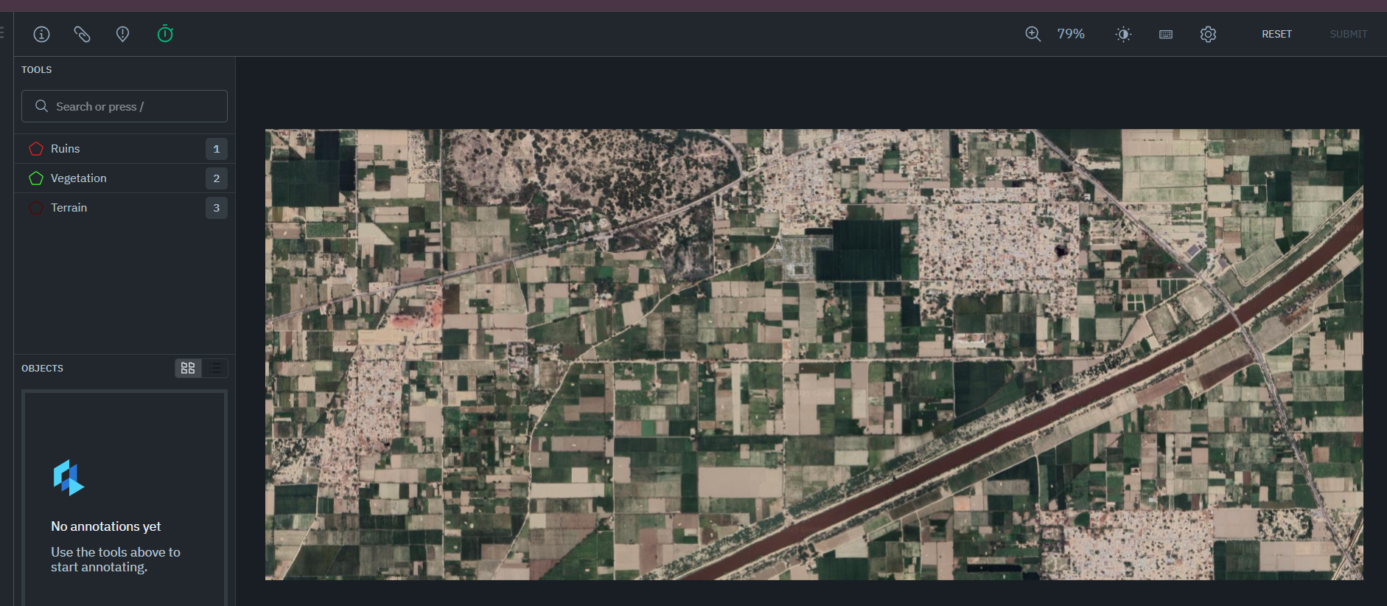

## **Day 5: Initial Image Annotation**

| **Class** | **Labeling Guidelines** |
| --- | --- |
| Ruins | Stone walls, foundations, rectangular structures |
| Vegetation | Dense tree canopy, forest regions |
| Terrain | Open land, non-vegetated areas |

**Activities Performed:**

* Labeled ~12–13 images per class.
* Used polygon tool for precise boundaries.
* Skipped unclear images.  
  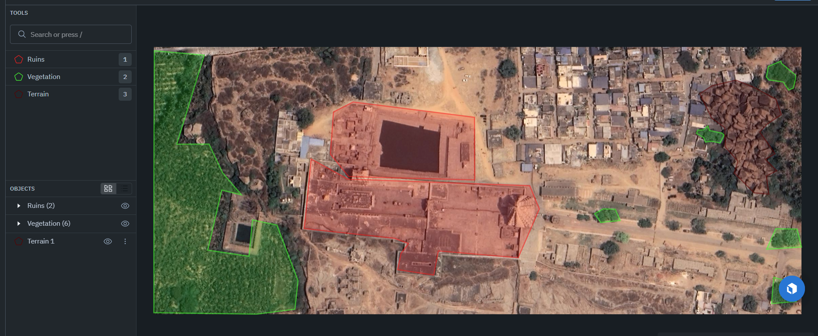

## **Day 6: Annotation Review & Export**

| **Aspect** | **Details** |
| --- | --- |
| Export Format | NDJSON |
| Review Type | Manual verification |

**Activities Performed:**

* Reviewed labeled images.
* Corrected over-labeling and inconsistencies.
* Exported annotations for mask generation.

## **Day 7: Mask Generation & Dataset Split**

| **Task** | **Description** |
| --- | --- |
| Mask Generation | Converted polygons to pixel masks |
| Dataset Split | Train–Validation split |

**Activities Performed:**

* Converted Labelbox annotations to segmentation masks.
* Generated mask images corresponding to each input image.
* Split dataset into training and validation sets.

### **Result of Milestone 1**

| **Outcome** | **Status** |
| --- | --- |
| Satellite dataset collected | Done |
| Images annotated | Done |
| Masks generated | Done |
| Dataset ready for training | Done |

**MILESTONE2: MODEL IMPLEMENTATION, TRAINING & EVALUATION**

## **Day 1: Model Selection & Design**

| **Aspect** | **Details** |
| --- | --- |
| Model Chosen | U-Net |
| Task | Semantic Segmentation |
| Framework | PyTorch |

**Activities Performed:**

* Studied U-Net architecture.
* Selected U-Net for pixel-wise segmentation.
* Planned encoder-decoder structure.

## **Day 2: Dataset Loader & Preprocessing**

| **Task** | **Description** |
| --- | --- |
| Dataset Loader | Custom PyTorch Dataset |
| Preprocessing | Resize, normalize |

**Activities Performed:**

* Implemented dataset loading pipeline.
* Loaded image–mask pairs.
* Verified input dimensions.

## **Day 3: Data Augmentation**

| **Technique** | **Purpose** |
| --- | --- |
| Horizontal Flip | Orientation invariance |
| Vertical Flip | Data diversity |
| Rotation | Robustness |

**Activities Performed:**

* Applied augmentation on training data.
* Increased effective dataset size.
* Improved model generalization.

## **Day 4: Model Training**

| **Parameter** | **Value** |
| --- | --- |
| Optimizer | Adam |
| Loss Function | Cross-Entropy |
| Epochs | 10–20 |
| Hardware | CPU |

**Activities Performed:**

* Trained U-Net model.
* Monitored training loss.
* Saved trained model weights.

## **Day 5: Evaluation Metric Implementation**

| **Metric** | **Purpose** |
| --- | --- |
| IoU | Overlap accuracy |
| Dice Score | Segmentation similarity |

**Activities Performed:**

* Implemented IoU and Dice Score calculation.
* Created evaluation script.
* Loaded trained model for testing.

## **Day 6: Model Evaluation & Results**

| **Class** | **IoU (%)** | **Dice (%)** |
| --- | --- | --- |
| Ruins | 2.43 | 3.63 |
| Vegetation | 7.85 | 4.33 |
| Terrain | 15.20 | 15.44 |
| **Overall Mean** | **8.49** | **7.8** |

**Activities Performed:**

* Evaluated model on labeled data.
* Observed class imbalance effects.
* Analyzed performance limitations.

## **Day 7: Result Analysis & Documentation**

| **Observation** | **Explanation** |
| --- | --- |
| Low IoU for ruins | Limited labeled data |
| Vegetation confusion | Visual similarity with terrain |
| Terrain dominance | Class imbalance |

**Activities Performed:**

* Interpreted results.
* Documented challenges.
* Identified future improvement scope.

### **Result of Milestone 2**

| **Outcome** | **Status** |
| --- | --- |
| U-Net implemented | Done |
| Model trained | Done |
| IoU & Dice evaluated | Done |
| Results analyzed | Done |

**Object Detection using YOLO**

## **Day 1: Understanding YOLO and Its Role in the Project**

| **Aspect** | **Details** |
| --- | --- |
| Topic Studied | YOLO (You Only Look Once) |
| Task Type | Object Detection |
| Difference Studied | Semantic Segmentation vs Object Detection |

**Activities Performed:**

* Studied the concept of YOLO (You Only Look Once).
* Understood how YOLO performs real-time object detection using a single neural network.
* Learned the difference between:  
  + **Semantic Segmentation (U-Net)** – pixel-level classification
  + **Object Detection (YOLO)** – bounding box–level detection
* Analyzed how YOLO can be applied to detect archaeological artifacts and structures within segmented ruin regions.

## **Day 2: YOLO Architecture and Workflow Study**

| **Component** | **Description** |
| --- | --- |
| Backbone | Feature extraction network |
| Neck | Feature aggregation |
| Head | Bounding box and class prediction |

**Activities Performed:**

* Studied YOLO architecture components.
* Learned how YOLO divides images into grids.
* Understood prediction of:  
  + Bounding boxes
  + Object confidence
  + Class probabilities
* Reviewed YOLOv5/YOLOv8 pipeline and differences between versions.

## **Day 3: Dataset Preparation for YOLO**

| **Aspect** | **Description** |
| --- | --- |
| Data Source | Google Earth Pro satellite imagery |
| Image Format | PNG |
| Classes Defined | Archaeological Structure |
| Annotation Tool | Labelbox |

### **Activities Performed:**

* Selected satellite images containing visible archaeological ruins.
* Defined a single detection class**: archaeological_structure.**
* Excluded vegetation, terrain, roads, and buildings from YOLO labeling.
* Created a YOLO-specific dataset separate from U-Net segmentation data.  
  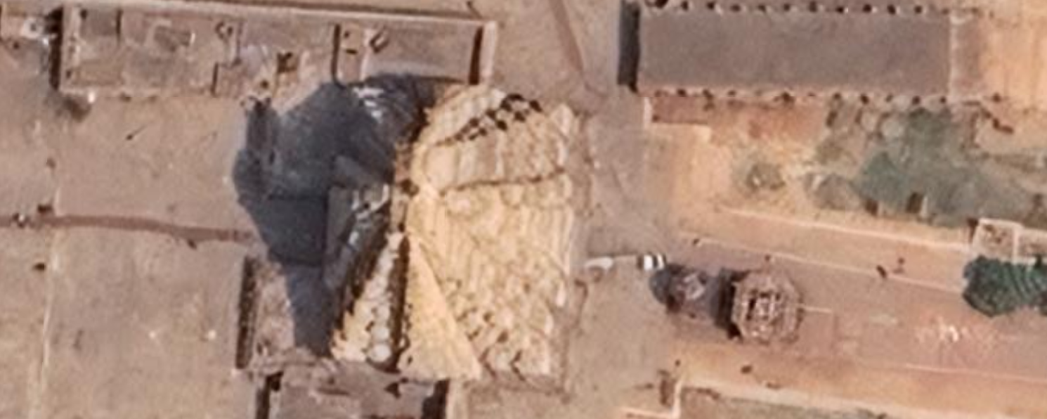

## **Day 4: Annotation of YOLO Dataset using Labelbox**

| **Annotation Type** | **Bounding Boxes** |
| --- | --- |
| Total Images Labeled | 27 |
| Validation Split | 7 images |
| Training Split | 20 images |

### **Activities Performed:**

* Created a new object detection project in Labelbox.
* Drew bounding boxes around archaeological structures only.
* Avoided overlapping and loose bounding boxes.
* Skipped images without visible archaeological structures.
* Exported annotations in NDJSON format.  
  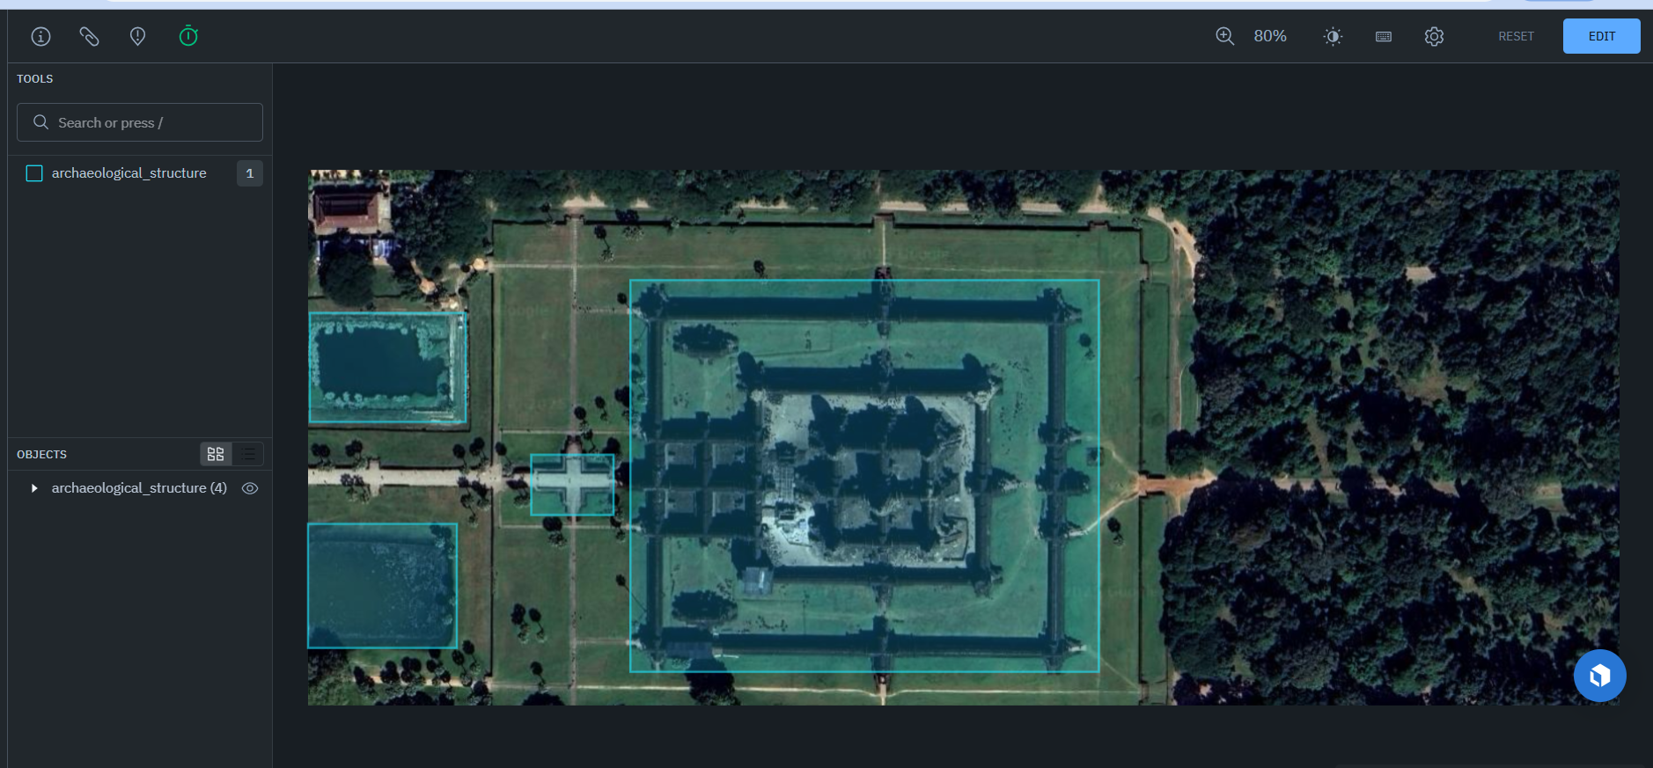

## **Day 5: Conversion to YOLO Format and Dataset Structuring**

| **File Type** | **Purpose** |
| --- | --- |
| .ndjson | Labelbox export |
| .txt | YOLO annotation files |
| data.yaml | YOLO dataset configuration |

### **Activities Performed:**

* Converted Labelbox annotations to YOLO format.
* Normalized bounding box coordinates.
* Organized dataset into:  
  + images/train, images/val
  + labels/train, labels/val
* Created YOLO configuration file (data.yaml).

## **Day 6: YOLO Model Training**

| **Parameter** | **Value** |
| --- | --- |
| Model Used | YOLOv8 Nano |
| Epochs | 50 |
| Image Size | 640 |
| Hardware | CPU |
| Framework | Ultralytics YOLO |

### **Activities Performed:**

* Installed Ultralytics YOLO framework.
* Trained YOLOv8 model on archaeological structure dataset.
* Monitored loss reduction and validation metrics.
* Saved best and last model weights.

## **Day 7: Model Evaluation and Results Analysis**

| **Metric** | **Value** |
| --- | --- |
| Precision | **97.4%** |
| Recall | **28.6%** |
| mAP@0.5 | **34.3%** |
| mAP@0.5:0.95 | **16.1%** |

### **Activities Performed:**

* Evaluated model on validation dataset.
* Analyzed detection quality using:  
  + Mean Average Precision (mAP)
  + Precision
  + Recall
* Observed that the model produced accurate detections with minimal false positives.

**Final Result of YOLO Model**

The YOLOv8 object detection model successfully detected archaeological structures from satellite imagery with high precision. Due to the limited dataset size, recall and mAP values were moderate. However, the results demonstrate the feasibility of using YOLO for archaeological site detection.

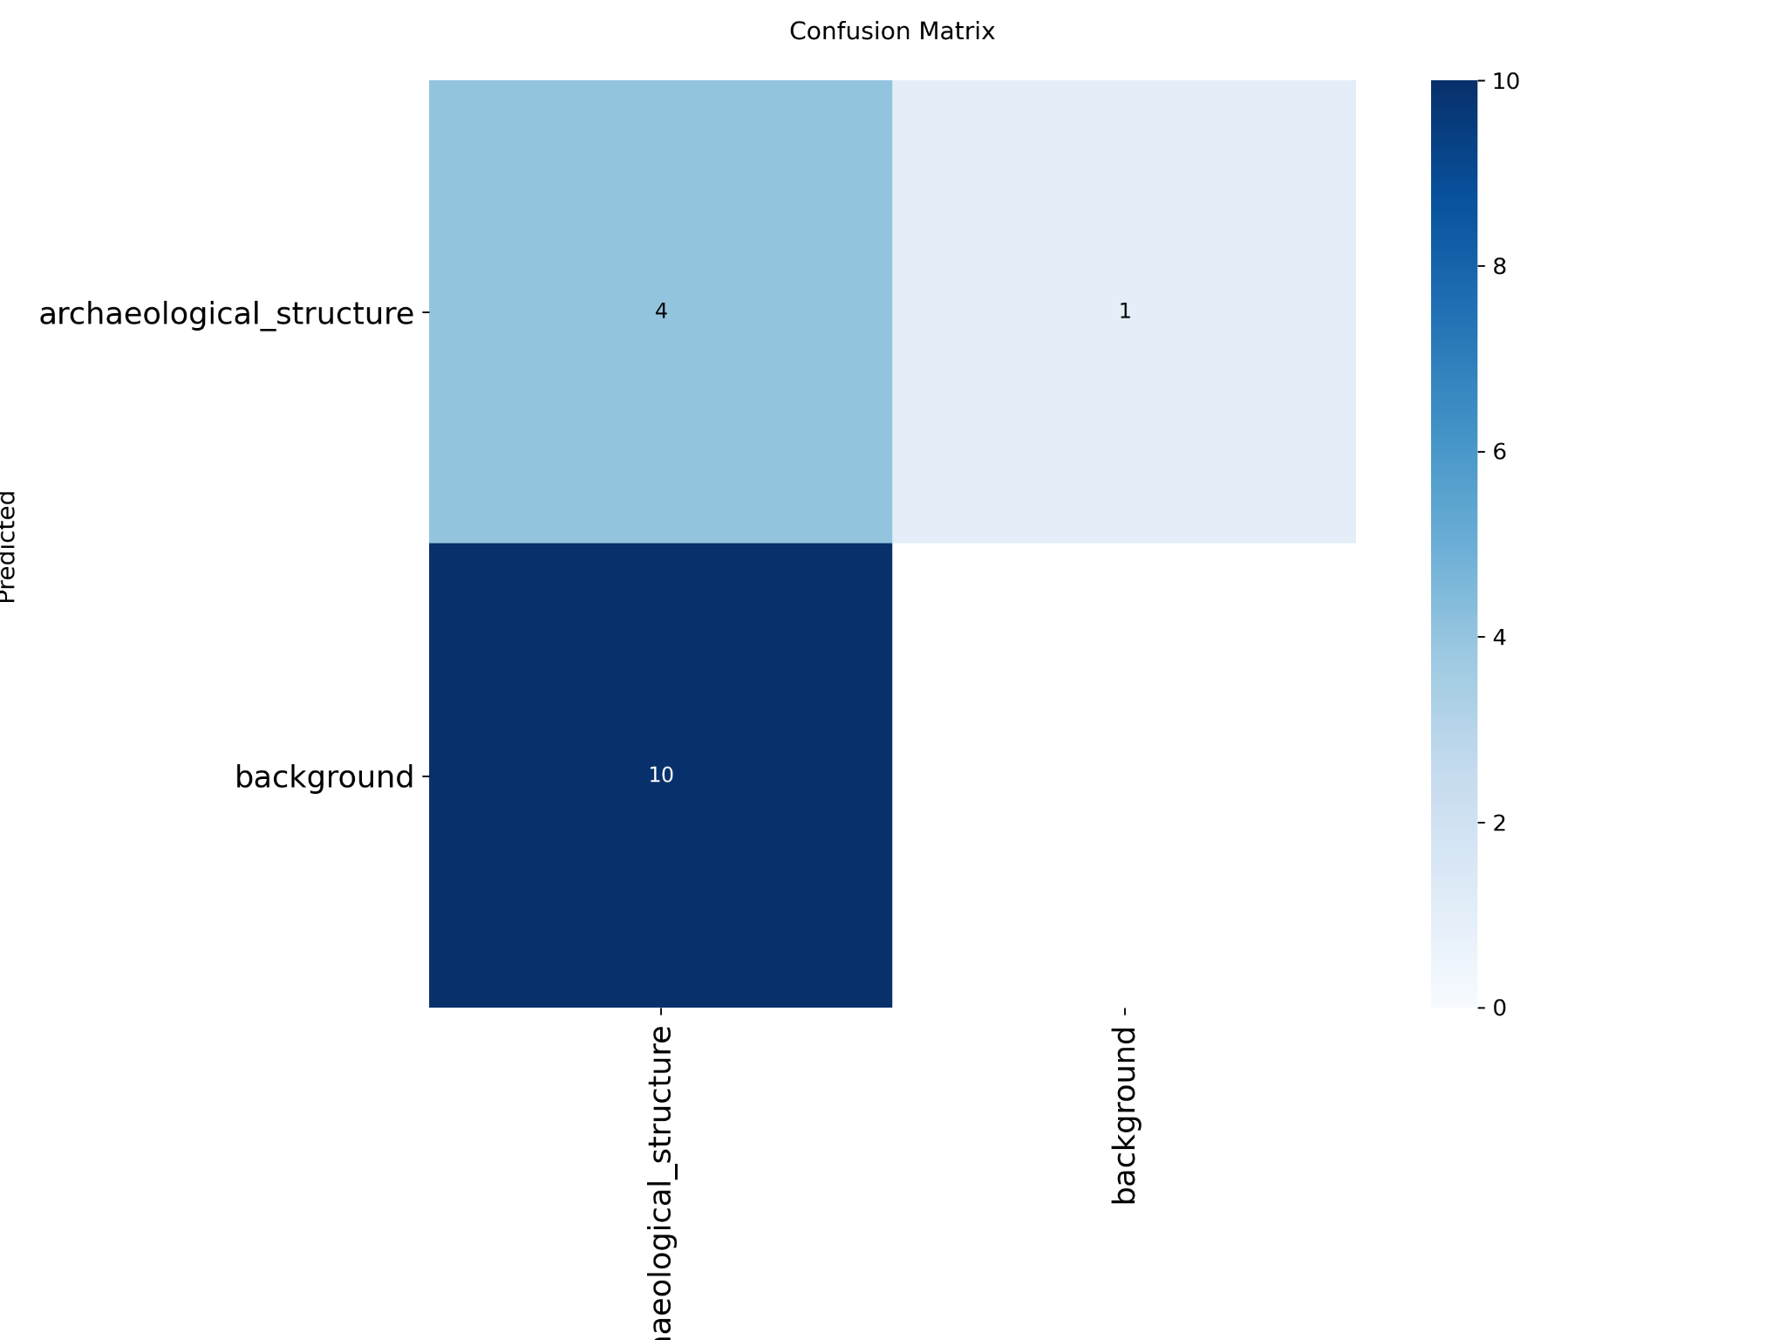

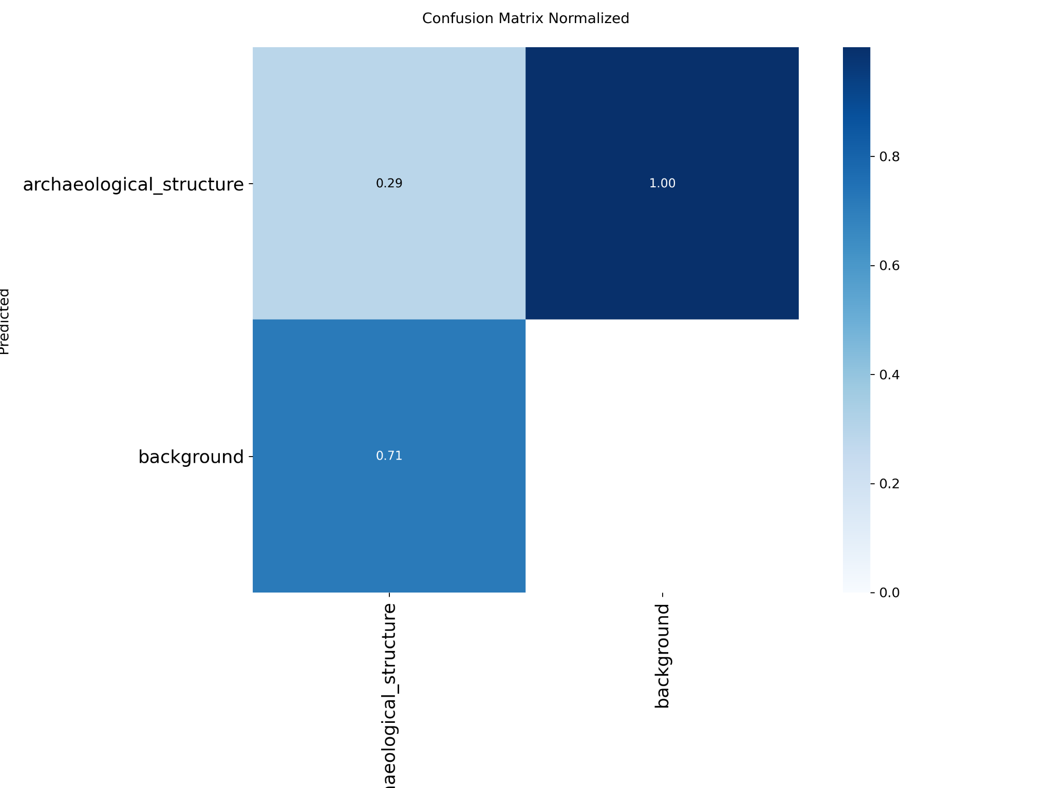

Trained Batch Image:

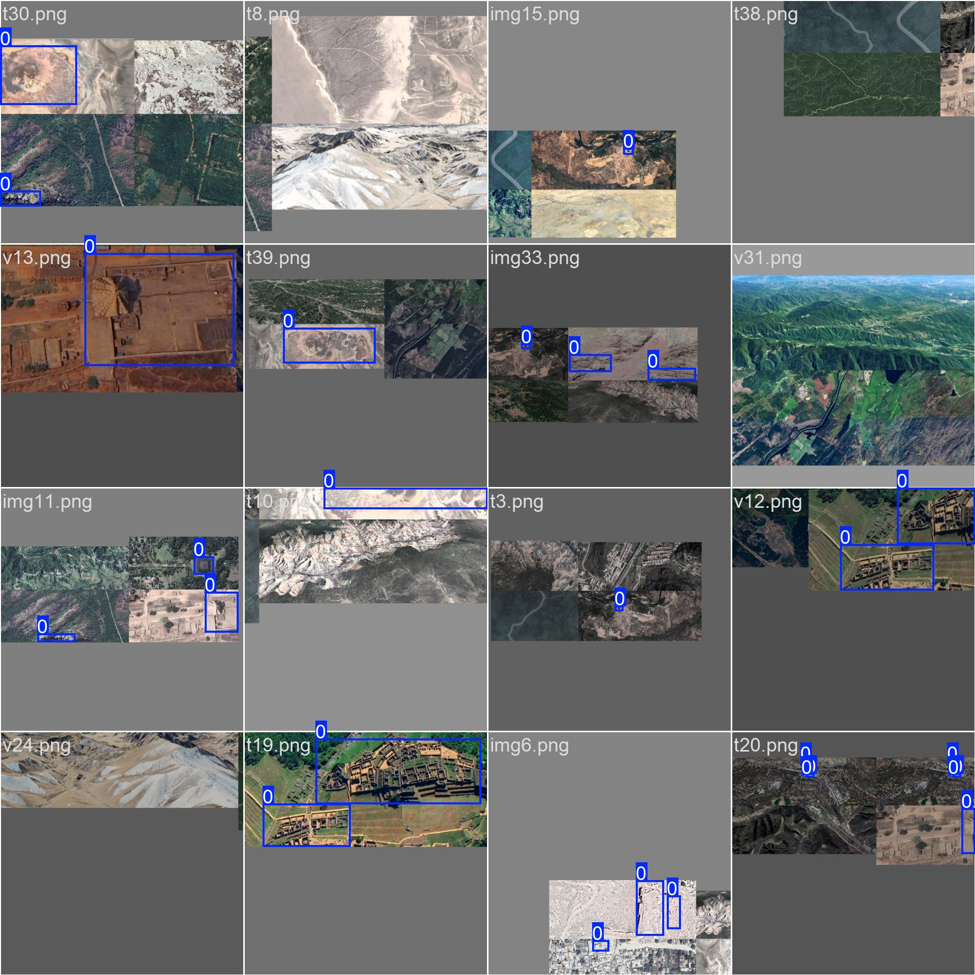

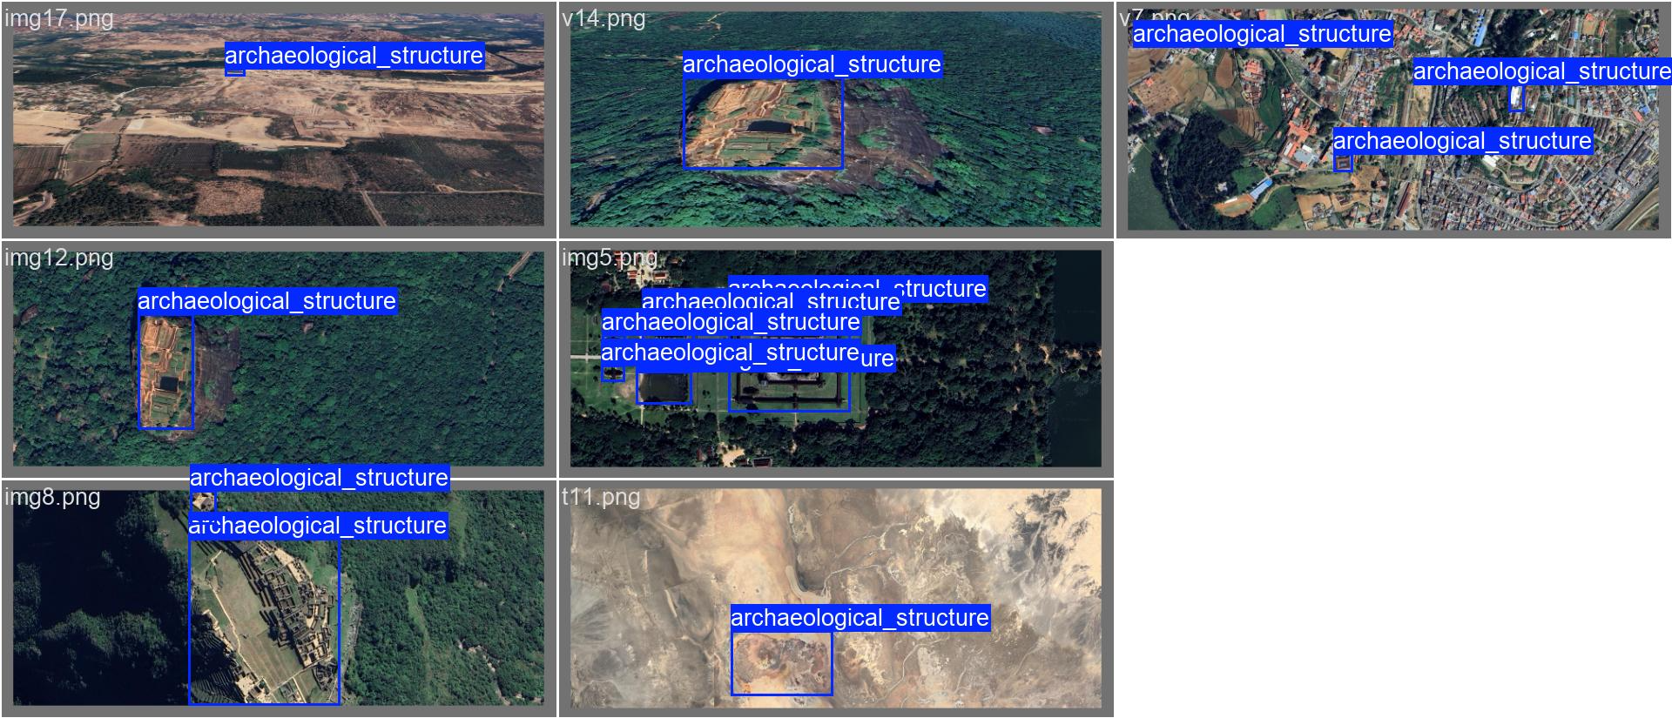

# **Milestone 3: Terrain Erosion Prediction (Weeks 5–6)**

## **Objective of Milestone 3**

The objective of this milestone is to predict terrain erosion risk and severity using machine learning models based on terrain-related features such as slope, elevation, vegetation cover, and terrain type.  
 This milestone focuses on analytical modeling, extending beyond image-based learning used in previous milestones.

**Week 5: Terrain Feature Collection and Dataset Preparation**

## **Day 1: Understanding Terrain Erosion and Feature Selection**

| **Aspect** | **Details** |
| --- | --- |
| Topic Studied | Terrain erosion concepts |
| Focus Area | Factors influencing soil and terrain erosion |
| Key Parameters | Slope, elevation, vegetation, terrain type |

### 

### 

### **Activities Performed:**

* Studied terrain erosion mechanisms such as water runoff, soil instability, and vegetation loss.
* Identified key terrain features that influence erosion:  
  + Slope angle
  + Elevation
  + Vegetation density
  + Terrain type (rocky, sandy, plateau, etc.)
* Analyzed how erosion-prone areas differ from stable regions using **Google Earth Pro observations**.

## **Day 2: Terrain Location Identification and Logical Labeling**

| **Aspect** | **Details** |
| --- | --- |
| Data Source | Google Earth Pro |
| Locations Used | Global terrain locations (mountains, deserts, plateaus) |
| Labeling Method | Manual + logical inference |

### **Activities Performed:**

* Selected multiple terrain locations using latitude and longitude from Google Earth Pro.
* Observed terrain characteristics such as:  
  + Steepness
  + Surface roughness
  + Vegetation sparsity
* Assigned binary erosion labels:  
  + 0 → Stable terrain
  + 1 → Erosion-prone terrain
* Created multiple variations per location by considering:  
  + Different slopes
  + Zoom levels
  + Terrain angles

## **Day 3: Dataset Creation and Feature Engineering**

| **Feature** | **Description** |
| --- | --- |
| Slope | Degree of incline |
| Elevation | Height above sea level |
| Vegetation | Categorical (Low, Medium, High) |
| Terrain_Type | Categorical (Rocky, Sandy, Plateau, etc.) |
| Erosion_Label | Binary classification |
| Erosion_Score | Continuous erosion severity (0–1) |

### **Activities Performed:**

* Created a structured dataset in CSV format.
* Encoded categorical features such as vegetation and terrain type.
* Added Erosion_Score to represent erosion severity using logical rules:  
  + High slope + sparse vegetation → higher erosion score
  + Flat terrain + dense vegetation → lower erosion score
* Augmented dataset by simulating observations from different angles and terrain variations.

# **Week 6: Model Training and Evaluation**

## **Day 4: Erosion Classification using Random Forest**

| **Aspect** | **Details** |
| --- | --- |
| Model Used | Random Forest Classifier |
| Task | Binary classification |
| Output | Erosion-prone vs Stable |

### **Activities Performed:**

* Implemented a Random Forest Classifier to predict erosion risk.
* Split dataset into training and testing sets.
* Evaluated the model using:  
  + Accuracy
  + Precision
  + Recall
  + F1-score

### **Results:**

* Achieved high classification accuracy due to strong correlation between terrain features and erosion risk.
* Model successfully differentiated erosion-prone and stable areas.

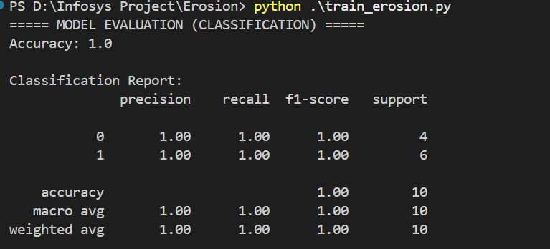

## **Day 5: Erosion Severity Prediction using Regression**

| **Aspect** | **Details** |
| --- | --- |
| Model Used | Random Forest Regressor |
| Task | Predict erosion severity |
| Output | Continuous erosion score |

### **Activities Performed:**

* Implemented Random Forest Regression to predict erosion severity.
* Used terrain features as input and erosion score as output.
* Evaluated model using:  
  + RMSE (Root Mean Square Error)
  + R² Score

### **Results:**

* RMSE: **0.064**
* R² Score: **0.945**

This indicates that the model explains **94.5% of the variance** in erosion severity, demonstrating strong predictive capability.

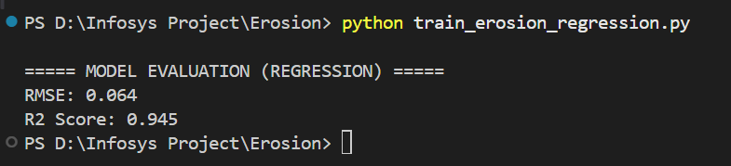

## **Day 6: Result Interpretation and Analysis**

| **Metric** | **Interpretation** |
| --- | --- |
| RMSE | Low prediction error |
| R² Score | Strong correlation between features and erosion |
| Classification Accuracy | Reliable erosion risk identification |

### **Activities Performed:**

* Interpreted model performance in an academic context.
* Analyzed limitations such as:  
  + Small dataset size
  + Logical data generation
* Documented results and observations for project reporting.

# **Milestone 4: Evaluation, Visualization, and Final Reporting (Weeks 7–8)**

## **Objective of Milestone 4**

The objective of this milestone is to evaluate all trained models, build an interactive visualization dashboard, integrate the outputs of YOLO Object Detection and Terrain Erosion Prediction, and prepare final documentation and presentation/demo for project submission.

# **Week 7: Interactive Dashboard Development and Model Integration**

## **Day 1: Understanding Dashboard Tools & Planning Integration**

| **Aspect** | **Details** |
| --- | --- |
| Topic Studied | Streamlit for ML dashboards |
| Goal | Build a project demo interface |
| Reason | Visualize outputs for mentor review & final demo |

### **Activities Performed:**

* Studied the use of Streamlit for interactive machine learning dashboards.
* Planned the dashboard flow for the project modules:  
  + Object Detection using YOLO
  + Terrain Erosion Prediction using ML
* Defined minimum dashboard requirements:  
  + Image selection/upload
  + Output visualization
  + Summary metrics and analysis

## **Day 2: Setting up Project Dashboard Structure**

| **Component** | **Purpose** |
| --- | --- |
| app.py | Main Streamlit dashboard file |
| input_images/ | Stores sample satellite images |
| results/ | Stores model output images |
| erosion_dataset_augmented.csv | Input for erosion prediction results |

### **Activities Performed:**

* Created a separate folder structure for dashboard implementation.
* Organized project files into clean directories for:  
  + Input images
  + YOLO predicted images
  + Erosion dataset
* Installed required libraries:  
  + streamlit
  + pandas
  + Pillow

## **Day 3: Integration of YOLO Object Detection Results**

| **Aspect** | **Details** |
| --- | --- |
| Model Used | YOLOv8 |
| Task Type | Object detection |
| Output | Bounding boxes + confidence score |

### **Activities Performed:**

* Trained YOLO model earlier and used the trained weights (best.pt) for prediction.
* Executed YOLO prediction command to generate inference outputs:  
  + Created predicted output folder such as predict2/
  + Generated predicted images with bounding boxes
  + Generated label files with confidence values (labels/*.txt)
* Integrated YOLO prediction visualization in dashboard:  
  + Displayed original image
  + Displayed detected output image
  + Showed detection count and confidence scores

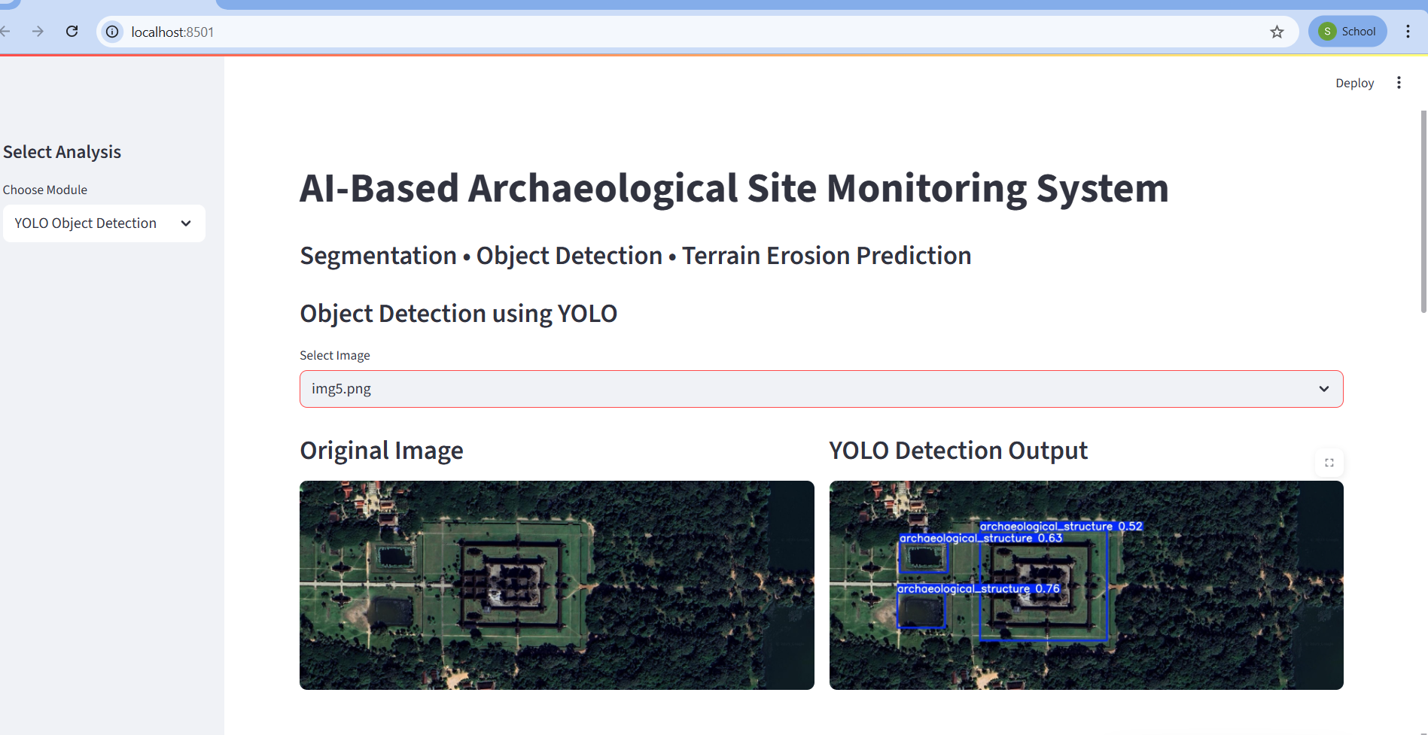

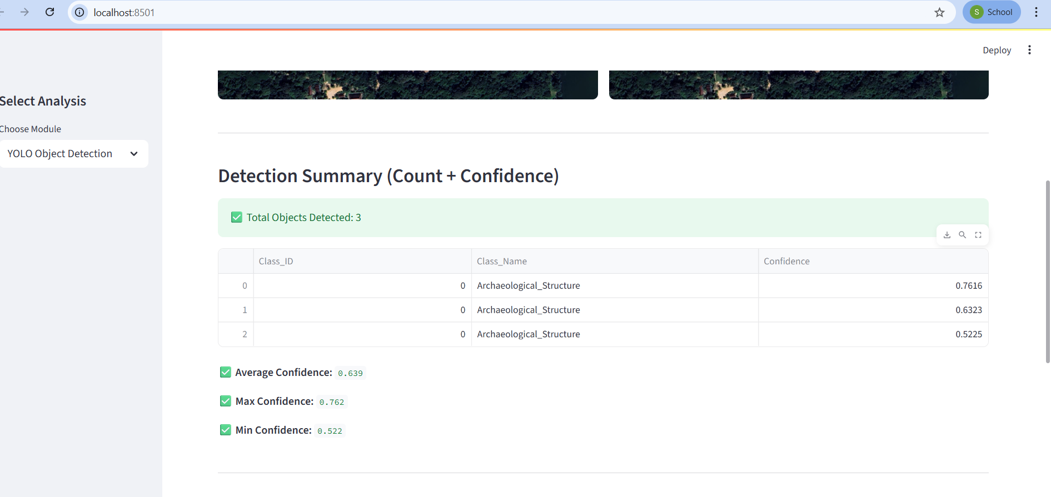

## **Day 4: Integration of YOLO Metrics and Performance Visualization**

| **Metric** | **Meaning** |
| --- | --- |
| Precision | Correct detections / total detections |
| Recall | Correct detections / total ground truth objects |
| mAP@50 | Accuracy at IoU threshold 0.5 |
| mAP@50–95 | Overall detection accuracy across multiple IoUs |

### **Activities Performed:**

* Extracted YOLO training metrics from results.csv.
* Displayed YOLO training and evaluation metrics in Streamlit dashboard.
* Added graphs and tables for final epoch performance:  
  + mAP
  + precision
  + recall
* Verified model performance for project demonstration.

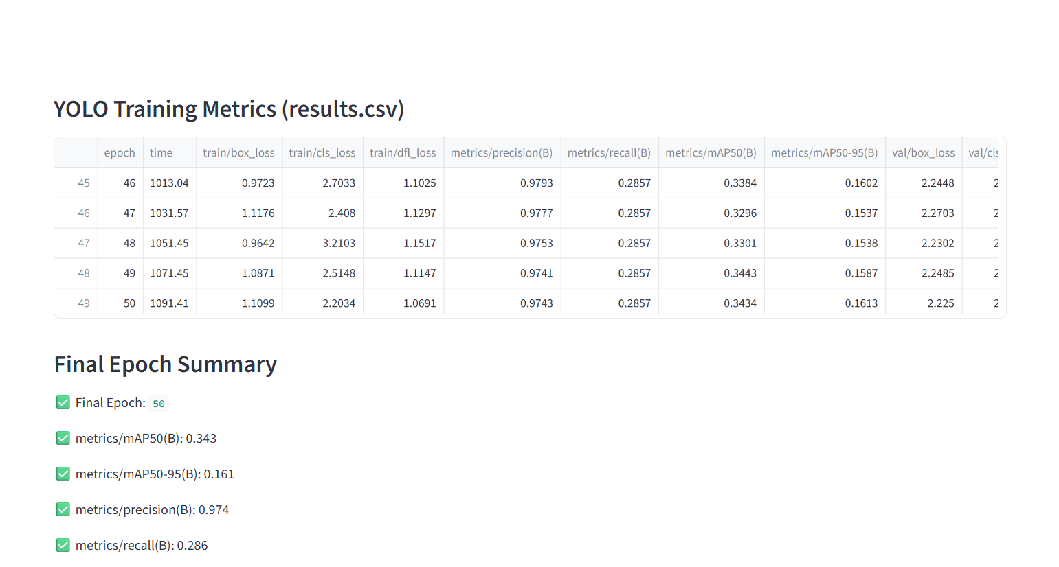

## **Day 5: Erosion Dataset Visualization in Dashboard**

| **Aspect** | **Details** |
| --- | --- |
| Task | Terrain erosion prediction |
| Dataset | erosion_dataset_augmented.csv |
| ML Models | Random Forest Classifier + Regressor |

### **Activities Performed:**

* Loaded erosion dataset into dashboard.
* Improved visualization of erosion analysis:  
  + Filter options (terrain type, vegetation, erosion label)
  + Displayed dataset summary cards:  
    - Total records
    - Stable vs erosion-prone count
    - Average erosion score
* Added dataset charts:  
  + Erosion risk distribution
  + Average erosion score by terrain type

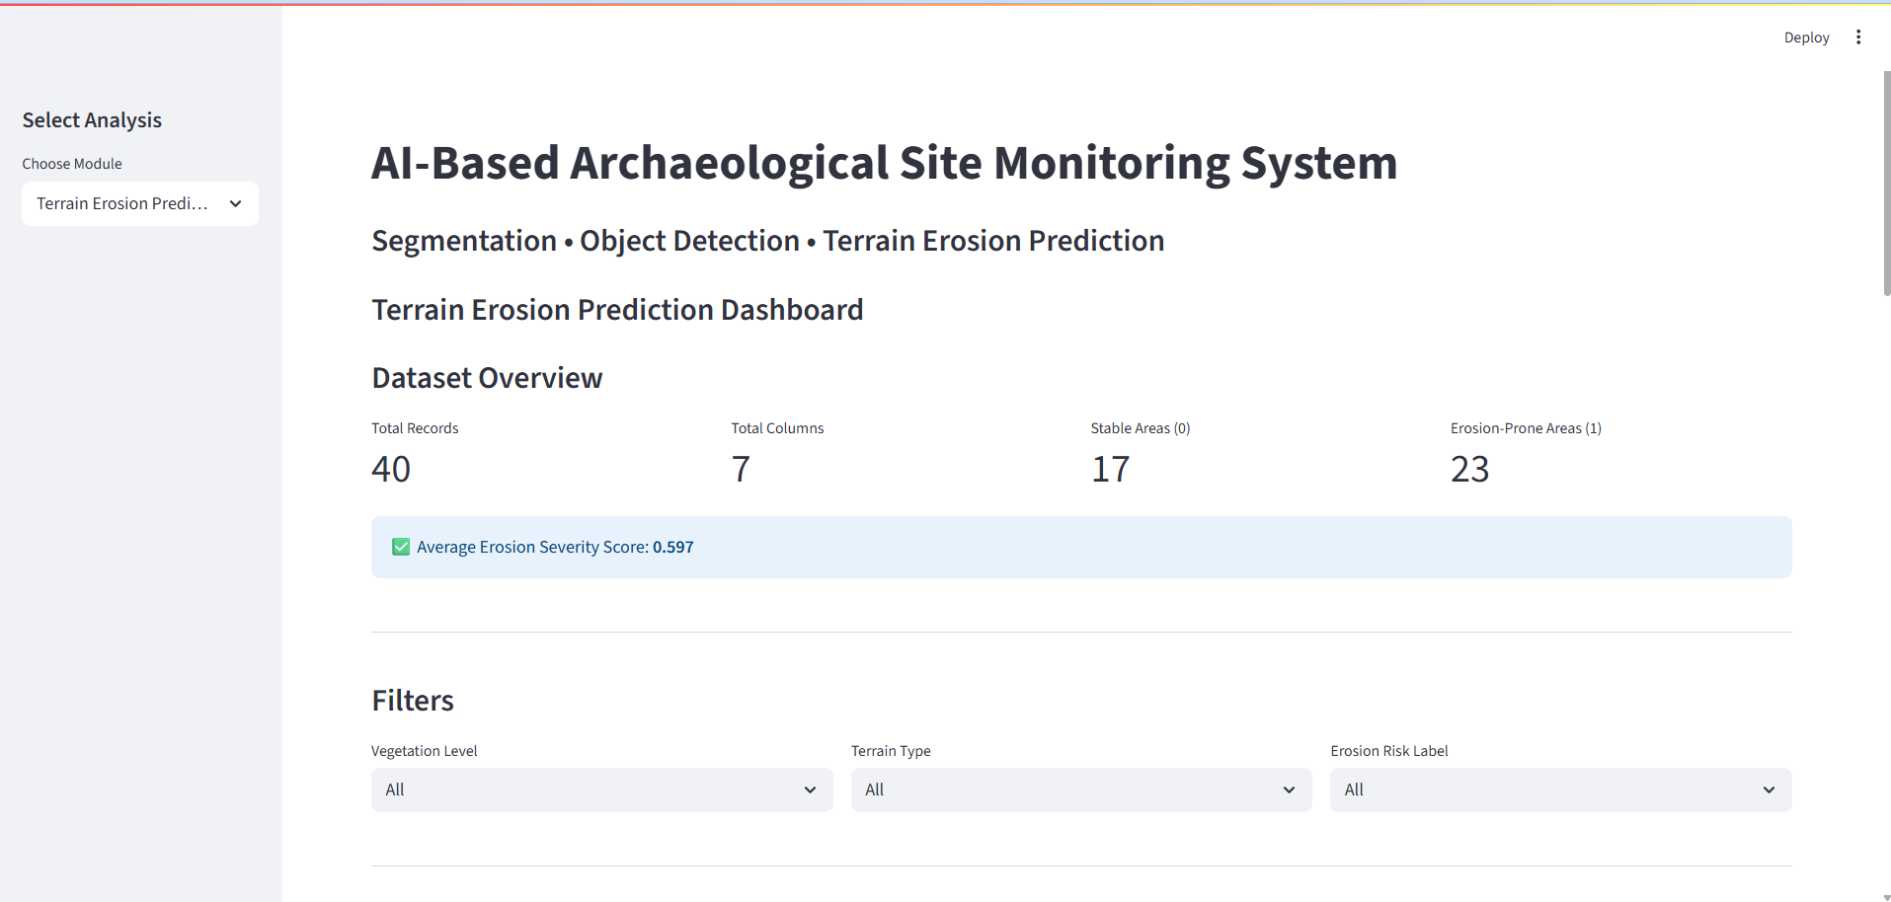

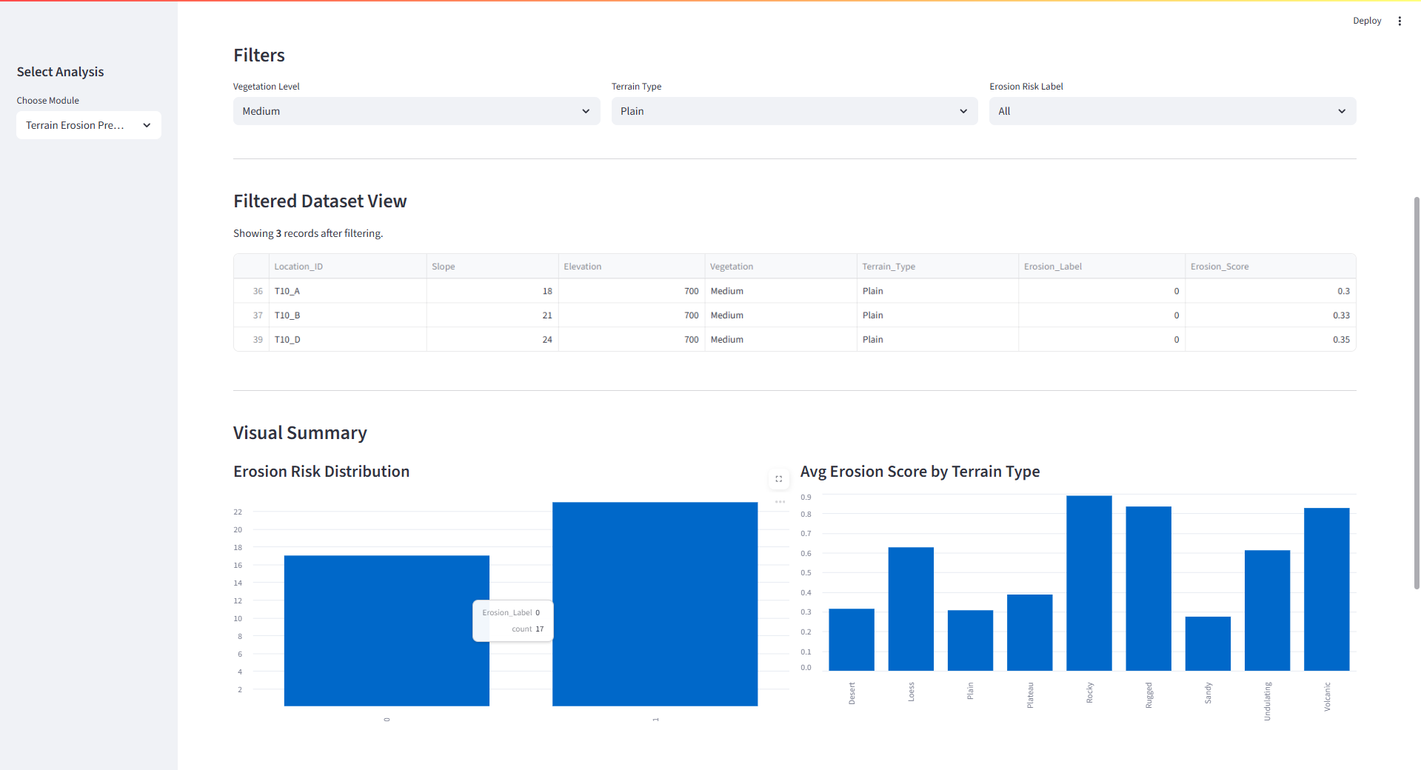

## **Day 6: Final Evaluation Summary of All Models**

| **Module** | **Task** | **Metric Used** | **Result** |
| --- | --- | --- | --- |
| YOLOv8 | Object detection | mAP@50 | ~0.34 |
| Erosion (Classifier) | Risk prediction | Accuracy | High |
| Erosion (Regressor) | Severity prediction | RMSE, R² | RMSE: 0.064, R²: 0.945 |

### **Activities Performed:**

* Collected final outputs and results from each model.
* Compiled model performance metrics for final report.
* Prepared evaluation screenshots for submission.

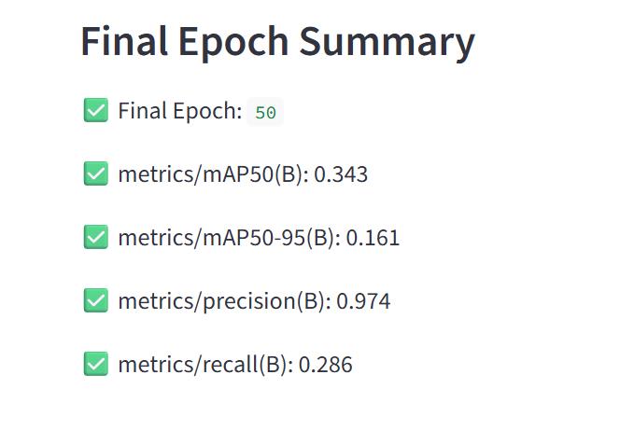

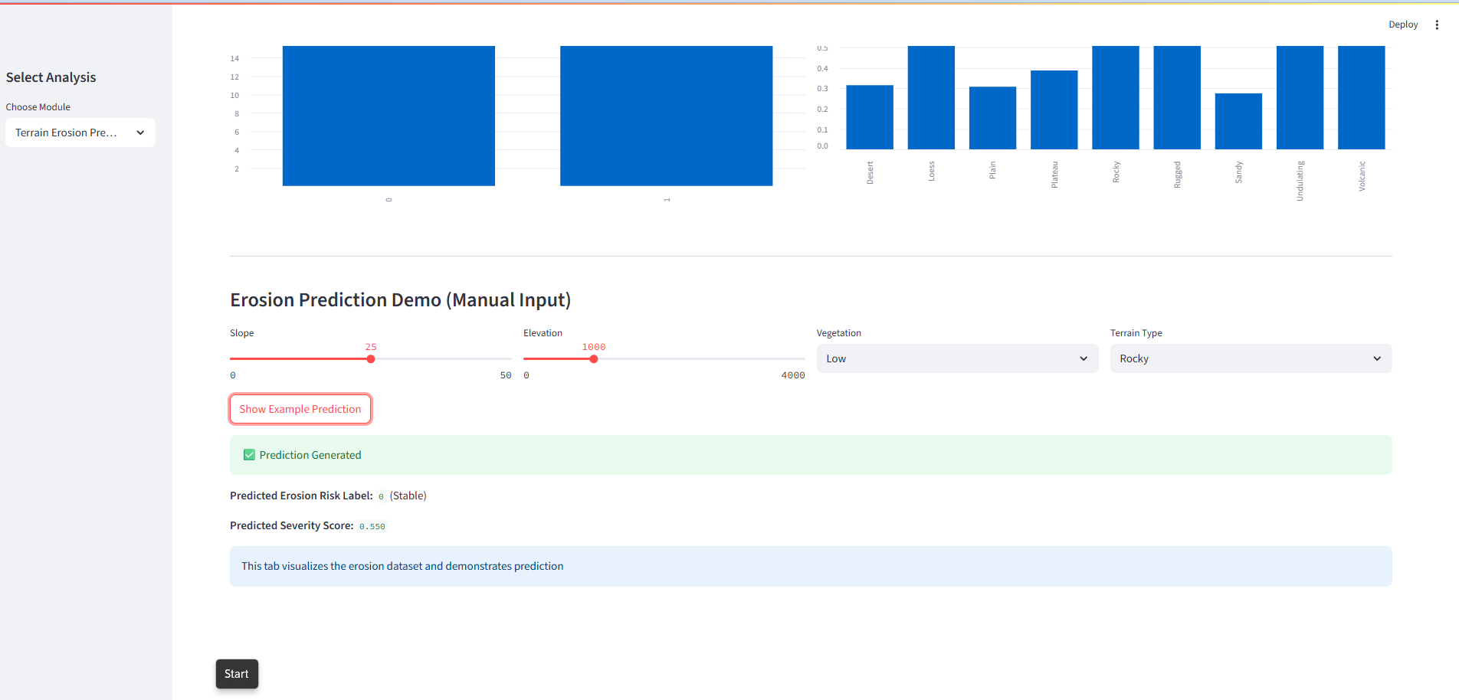

**Result of Milestone 4**

* Successfully built a working **Streamlit dashboard** for project visualization.
* Integrated **YOLO detection results** including:  
  + Bounding boxes
  + Confidence values
  + Detection counts
  + Training metrics (mAP, precision, recall)
* Integrated **Terrain Erosion Prediction dataset visualization** with:  
  + Filters
  + Summary cards
  + Charts